WG Cereal w/gram crackers  Fruit  100% Fruit juice  Low fat or Fat Free Milk  29 | WG French Toast Sticks /syrup  Fruit  100% Fruit Juice  Low Fat or Fat Free  30 | WG Bagel w/toppings  Fruit  100% Fruit Juice  Low Fat or Fat Free Milk  31 | Sausage egg and cheese Muffin  Fruit  100% Fruit Juice  Low Fat or Fat Free Milk  1 | No School  2
Spring Break  5 | Spring Break  6 | Spring Break  7 | Spring Break  8 | Spring Break  9
WG Cereal w/gram crackers  Fruit  100% Fruit juice  Low fat or Fat Free Milk  12 | WG Bagel w/cream cheese  Cran Raisins  Sting cheese Stick  Low Fat or Fat Free Milk  13 | Wg Dutch Waffle  Fruit  100% Fruit juice  Low Fat or Fat Free Milk  14 | Bacon egg and cheese Biscuit  Fruit  100% Fruit Juice  Low Fat or Fat Free Milk  15 | WG French Toast sticks w/syrup  Hard-boiled Egg  Fruit  100% Fruit Juice  Low Fat or Fat Free Milk  16
WG Cereal w/gram crackers  Fruit  100% Fruit juice  Low fat or Fat Free Milk  19 | WG Breakfast Pizza  Cran Raisins  Sting cheese Stick  Low Fat or Fat Free Milk  20 | Wg French Toast sticks  Fruit  100% Fruit juice  Low Fat or Fat Free Milk  21 | Bacon egg and cheese Biscuit  Fruit  100% Fruit Juice  Low Fat or Fat Free Milk  22 | WG Cereal Bar w/Graham crackers  Hard-boiled Egg  Fruit  100% Fruit Juice  Low Fat or Fat Free Milk  23
WG Cereal w/gram crackers  Fruit  100% Fruit juice  Low fat or Fat Free Milk  26 | WG Cini Mini  Cran Raisins  Sting cheese stick  Low Fat or Fat Free Milk  27 | WG Bagel/crm cheese  Fruit  100% fruit juice  Low Fat or Fat Free Milk  28 | Sausage egg and cheese Muffin  Fruit  100% Fruit Juice  Low Fat or Fat Free Milk  29 | WG French Toast Sticks /syrup  Fruiit  100% Fruit Juice  Low Fat or Fat Free Milk  30
* Menu subject to change without notice*This institution and the USDA are equal opportunity employers
Office of School Nutrition Director Myra Trumbull 518-568-2014 Ext 3130

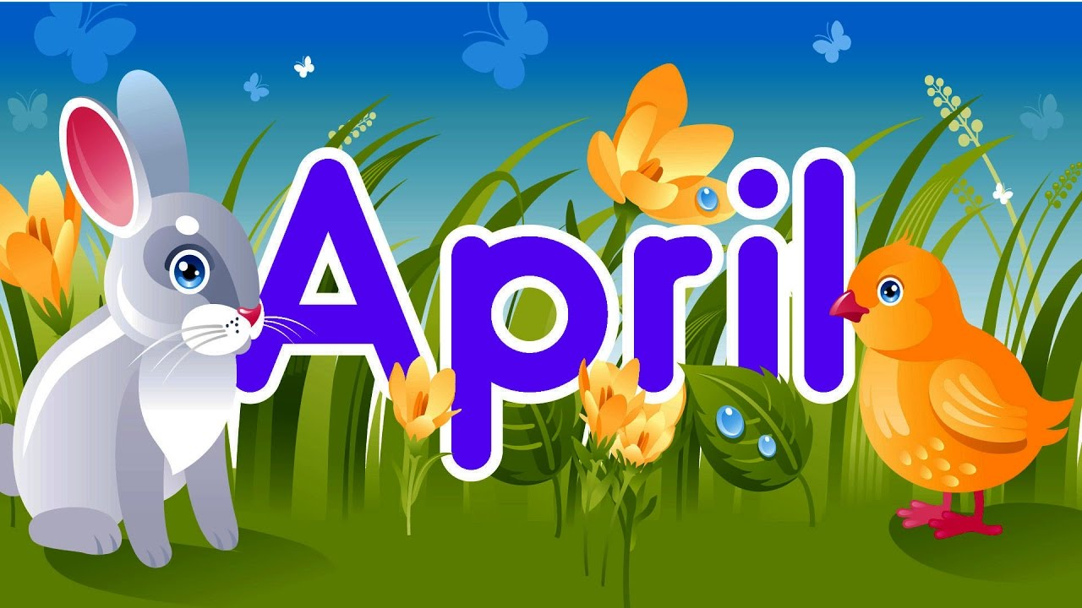
Oven Baked Chicken  Cooked carrots(RO)  Mashed Potatoes(S)  Assorted fruit  Low Fat or Fat Free Milk  29 | Soft Taco w/toppings  Garlic Buttered Green Beans (O)  Baby Carrots w/dip(RO)  Assorted fruit  Low Fat or Fat Free Milk  30 | Turkey and Cheese Sandwich  Buttered Corn(S)  Assorted fruit  Low Fat or Fat Free Milk  31 | Philly Cheese Wrap  Cole slaw  Vegetarian Beans (BL)  Sweet Potato tots(RO)  Assorted fruit  Low Fat or Fat Free Milk  1 | No School  2
Spring Break  5 | Spring Break  6 | Spring Break  7 | Spring Break  8 | Spring Break  9
BBQ Pulled Pork Sandwich  Baked beans(BL)  Sweet potato tots(RO)  Coleslaw(O)  Assorted fruit Choice  Low fat or Fat Free Milk  12 | Taco Salad  Cooked Carrots(RO)  Assorted Fruit choice  Low Fat or Fat Free Milk  13 | Grilled chicken Cordon Bleu Sandwich  Buttered Corn(S)  Assorted fruit choice  Low Fat or Fat Free Milk  14 | Turkey /Gravy  Mashed Potatoes(S)  Creamed Spinach(DG)  WG Dinner roll  Assorted Fruit choice  Low Fat or Fat Free Milk  15 | French bread Pizza  Steamed Broccoli Florets(DG)  Assorted fruit choice  Low Fat or Fat Free Milk  16
Oven Baked Chicken  Garlic Buttered Green Beans (O)  Potato Tots(S)  Soft Pretzel  Assorted Fruit choice  Low fat or Fat Free Milk  19 | Warm Ham & Cheese Bagel  Cooked Carrot slices(RO)  Vegetable soup  Assorted Fruit choice  Low Fat or Fat Free Milk  20 | Beef hot Dog on a bun  Vegetarian Beans (BL)  WG Sun chips  Assorted Fruit choice  Low Fat or Fat Free Milk  21 | Hamburger on a bun  Garlic Buttered green beans(O)  Chocolate cake w/frosting  Assorted Fruit Choice  Low Fat or Fat Free Milk  22 | Assorted Pizza  Broccoli Florets(DG)  Assorted Fruit choice  Low Fat or Fat Free Milk  23
Spaghetti w/meatballs  Green beans (O)  Pretzel roll  Assorted fruit choice  Low fat or Fat Free Milk  26 | Soft Taco w/toppings  Cooked Carrots slices(RO)  Assorted Fruit choice  Low Fat or Fat Free Milk  27 | Turkey & Cheese Sandwich  Baby Carrots(RO)  Assorted Fruit choice  Low Fat or Fat Free Milk  28 | Popcorn chicken  w/dipping sauce  soft pretzel  black beans (BL)  Buttered Corn (S)  Assorted Fruit choice  Low Fat or Fat Free Milk  29 | Assorted Pizza  Steamed Broccoli(DG)  Assorted Fruit choice  Low Fat or Fat Free Milk  30
* Menu subject to change without notice*This institution and the USDA are equal opportunity employers
Office of School Nutrition Director Myra Trumbull 518-568-2014 Ext 3130

