All Students enrolled in the OESJ school district will eat Free for the 2019-20 School Year.
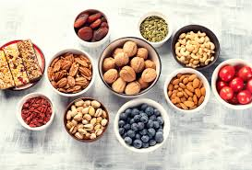
Snacks can be an important part of your diet. They can provide energy in the middle of the day or when you exercise. A healthy snack between meals can also decrease your hunger and keep you from overeating at meal time.
Healthy Snacking assist with your appetite control, increased energy and better over all concentration.
HEALTHY SNACK Suggestions
- Fresh Fruit-(Apples, Bananas,grapes,pineapple,Kiwi,Starwberries etc)
- Mini-bagels or muffins
- Fruit Cups
- Graham Crackers
- Applesauce
- Cheese Nips or Goldfish Crackers
- Raisins
- Bread/rolls with butter, peanut butter, or sugar free jelly
- Dried Fruit
- Pretzels or popcorn
- Fresh Vegetables (Broccoli, carrots, celery, cucumbers peppers, etc)
- Rice Cakes
- Grain and Fruit Bars
- Animal Crackers
- Trail mix without candy*
- Baked Chips
- Granola Bars*
- Cheese and Crackers
- Yogurt/Go-gurt
- String Cheese
- Fat-free Pudding
- Cheese Slice
- Nuts
- Hard boiled Eggs

