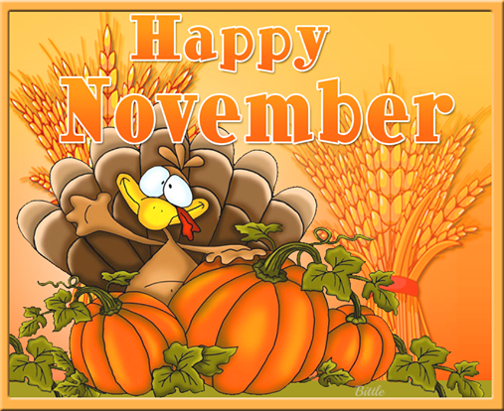
November 2019 Breakfast Menu
** Daily Alternate breakfast include: Cereal Bar, Bagel w/cream cheese, Yogurt or cereal w/graham crackers **
All Students Eat Free! |  |  |  | WG Banana Super Bread  Assorted Chilled Fruit  Choice of low fat or fat free Milk  1
WG Cereal Choice  Assorted Chilled Fruit  Choice of low fat or fat free Milk  4 | Mini Bagel pack w/crm cheese  Assorted Chilled Fruit  Choice of low fat or fat free Milk  5 | Bacon egg and cheese Biscuit  Assorted Chilled Fruit  Choice of low fat or fat free Milk  6 | WG Blueberry Muffin  Assorted Chilled Fruit  Choice of low fat or fat free Milk  7 | Mini Pancake pack w/syrup  Assorted Chilled Fruit  Choice of low fat or fat free Milk  8
No School  11 | Wg French Toast sticks  Assorted Chilled Fruit  Choice of low fat or fat free Milk  12 | Wg Cereal choice  Assorted Chilled Fruit  Choice of low fat or fat free Milk  13 | Pancake on a stick  Assorted Chilled Fruit  Choice of low fat or fat free Milk  14 | Wg Banana Super bread Assorted Chilled Fruit  Choice of low fat or fat free Milk  15
Blueberry Muffin  4 oz yogurt  Assorted Chilled Fruit  Choice of low fat or fat free Milk  18 | Wg mini Waffle pack  Assorted Chilled Fruit  Choice of low fat or fat free Milk  19 | Apple Frudel  Assorted Chilled Fruit  Choice of low fat or fat free Milk  20 | Sausage egg and cheese muffin  Assorted Chilled Fruit  Choice of low fat or fat free Milk  21 | No School Supt Day  22
Bagel/toppings  Assorted Chilled Fruit  Choice of low fat or fat free Milk  25 | Breakfast Burrito  Assorted Chilled Fruit  Choice of low fat or fat free Milk  26 | Thanksgiving Recess  27 | Thanksgiving Recess  28 | Thanksgiving Recess  29
Office of School Nutrition 518-568-2014 Ext #3130
* Menu subject to change without notice* This institution and the USDA are equal opportunity provider

November 2019 Lunch Menu
** Daily Alternates include: PBJ, Bagel w/cream cheese, Salad w/dressing or Yogurt w/dinner rolls **
 | ALL STUDENTS EAT FREE!! |  |  | Assorted Pizza  Buttered Corn (S)  Assorted Chilled fruit  choice  Low fat or Fat Free Milk  1
Chicken Tenders  Broccoli Florets (DG)  Dinner roll  Assorted Chilled fruit choice  Low fat or Fat Free Milk  4 | Warm Ham and Cheese  Bagel  Tomato Soup  Assorted Chilled fruit choice  Low fat or Fat Free Milk  5 | Beef Hot dog on a bun  Veg Beans  Chili  Assorted Chilled fruit choice  Low fat or Fat Free Milk  6 | Hamburger/Cheeseburger on a bun  Buttered Corn (S)  Assorted Chilled fruit choice  Low fat or Fat Free Milk  7 | Assorted Pizza  Romaine Salad w/dressing (DG)  Assorted Chilled fruit choice  Low fat or Fat Free Milk  8
Veterans Day-No School  11 | Chicken Patty on a bun  Buttery garlic green beans(O)  Assorted Chilled fruit choice  Low fat or Fat Free Milk  12 | BBQ Pork sandwich  Veg beans (BL)  Sweet Potato fries (RO)  Assorted Chilled fruit choice  Low fat or Fat Free Milk  13 | Turkey Gravy  Mashed Potatoes(S)  Sweet potatoes(RO)  Buttered Corn(S)  Assorted Chilled fruit choice  Low fat or Fat Free Milk  14 | Assorted Pizza  Broccoli Florets (DG)  Assorted Chilled fruit choice  Low fat or Fat Free Milk  15
Cheeseburger on a bun  Broccoli Florets (DG)  Assorted Chilled fruit choice  Low fat or Fat Free Milk  18 | Soft Beef Taco  Baked Beans (BL)  Chicken noodle soup  Assorted Chilled fruit choice  Low fat or Fat Free Milk  19 | Corn Dog  Garlic Buttery green beans  Potato smiles (S)  Assorted Chilled fruit choice  Low fat or Fat Free Milk  20 | Chicken Patty on a Bun  Buttered Corn (S)  Assorted Chilled fruit choice  Low fat or Fat Free Milk  21 | Supt. Conference Day  No School  22
Tangerine Orange Chicken  Brown Rice  Broccoli florets (DG)  Assorted Chilled fruit choice  Low fat or Fat Free Milk  25 | Assorted Pizza  Soft pretzel  Buttered corn (S)  Assorted Chilled fruit choice  Low fat or Fat Free Milk  26 | Thanksgiving recess  27 | Thanksgiving recess  28 | Thanksgiving recess  29
Office of School Nutrition 518-568-2014 Ext# 3130
* Menu subject to change without notice* This institution and the USDA are equal opportunity provider

